**Week 2 Report**

I collected data on Bloomerg’s Terminal, WIND, and the website of NBS.

Found and categorized the data into four perspectives: ownership/ sales/ production/ human.

The data can be compared within each perspective or yearly.

Note: the Excel called “meta data” is for storing the whole original numbers.

The followings are ideas which I assumed are news worthy.

**Chart 1 10-year growth in civilian-owned cars**

For this chart, I compiled civilian-owned cars ownership in 2008 to 2017. Also, I calculated the growth in 10 years by using the formula (ownership2017-ownership2008)/ownership2008

Guangdong, Jiangsu, Shandong, Zhejiang, Hebei are among the five provinces that own biggest amount of cars, specifically civilian-owned cars. Beijing has the least growth, making it dropping from top 6 in 2008 to top 14 in 2017. Provinces with fewer GDP, such as Guizhou, Gansu, Jiangxi, Ningxia, Guangxi surprisingly have more growth than other “developed provinces”.

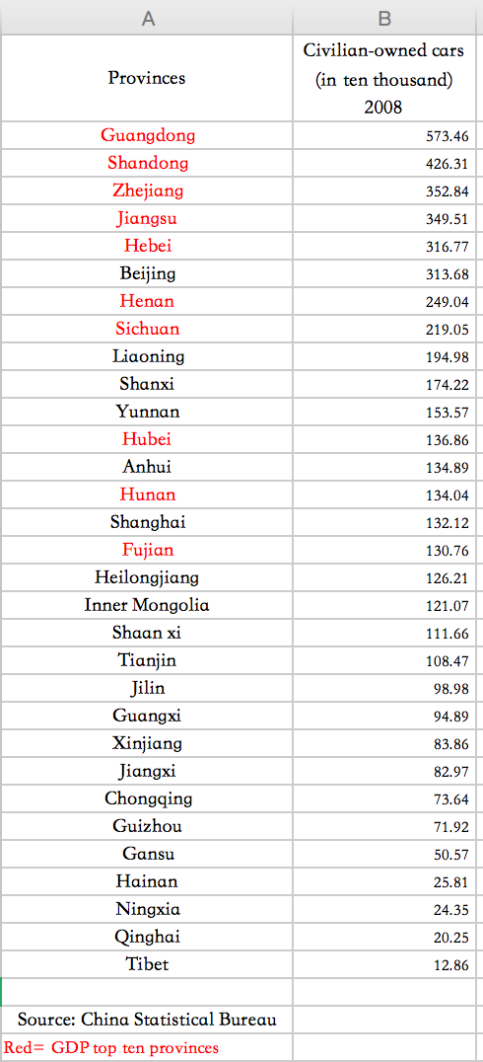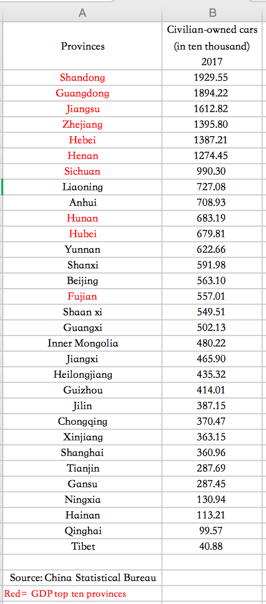 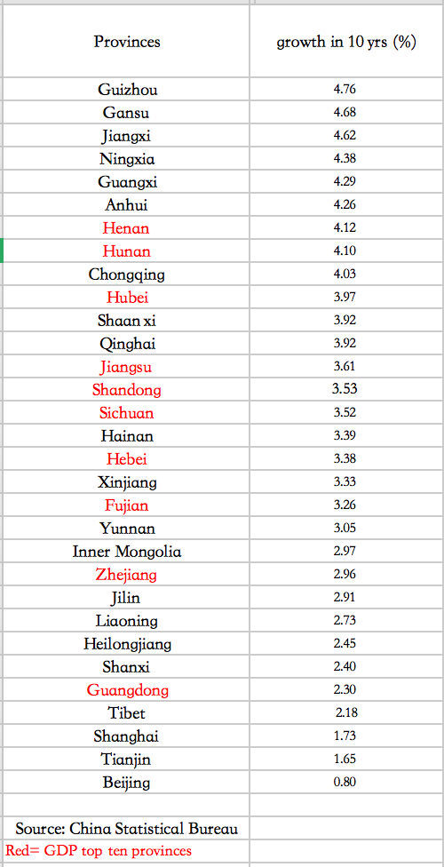

For visualization, I think we can try: putting ownership 2007 on left side and ownership 2018 on right side. Using lines to connect between two sides.

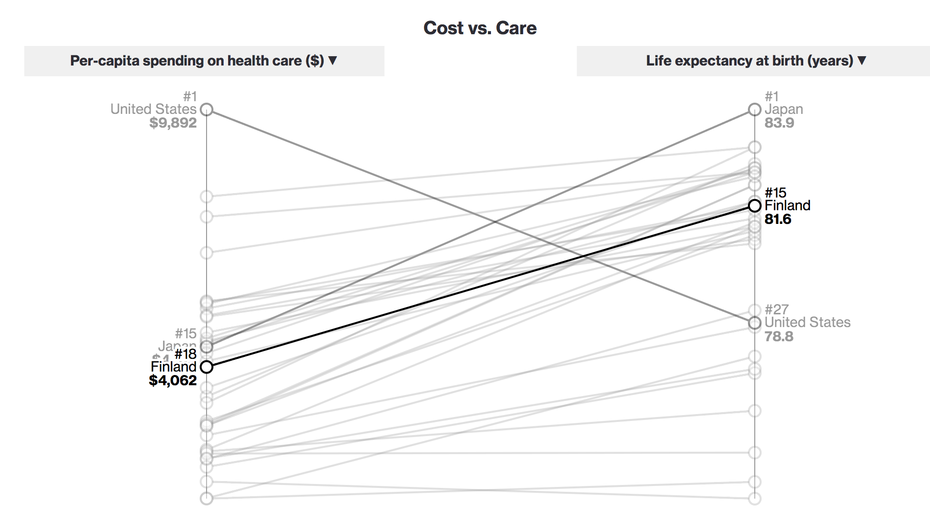

**Chart 2 & 3 Industrial Sales Value**

For this chart, I compiled industrial sales value in 2018 to 2015. Calculated the average sales value in eight years, Jilin, Hubei, Guangdong, Shanghai, Beijing and Chongqing have the biggest sales value on cars. Also, it is surprising that nearly every provinces, except Tibet, has car-related business.

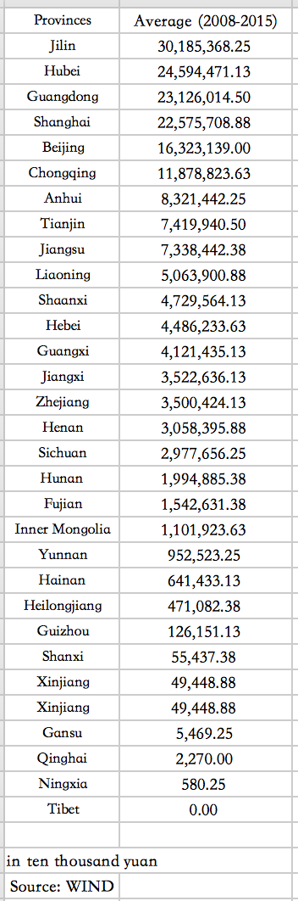 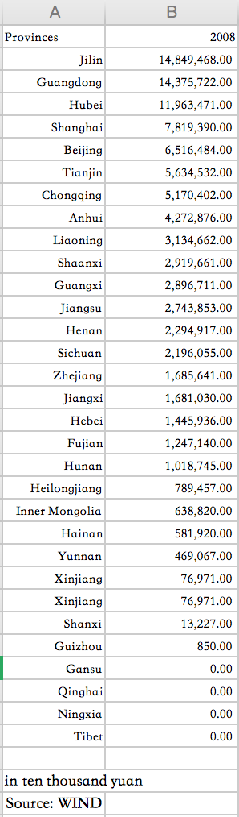 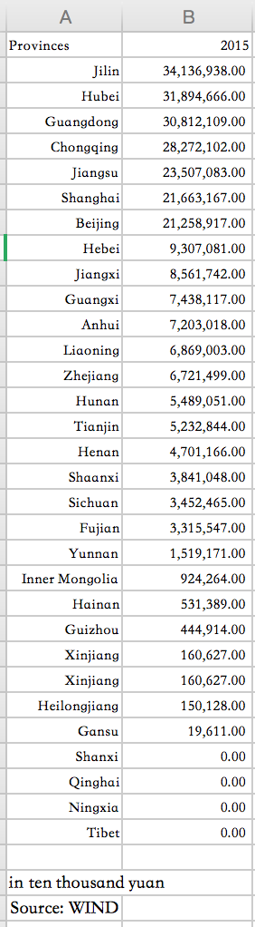

Jilin, located in the rust-belt region, has long been powered by car industry, because it is the only province that listed among top three sales value provinces but not in the TOP 10 GDP list. Jiangsu and Hebei climb upward the ranking while Tianjing drops from 6 to 15.

For visualization, we can try using map to present the volume of sales value according to different provinces by using traditional colors. Then presenting the change of ranking in sales value just like Chart 1 does.

**Chart 4 Production**

Surprisingly, all the provinces except Tibet, Qinghai and Ningxia, produce cars during 2006-2017. Shanghai, Chongqing, and Guangdong produce averagely largest amount of vehicles. Comparing average production (third table) with the average industrial sales value (second table) in the period of 2016-2015, I found Jilin produced less cars but with more value while Shanghai did just the opposite .

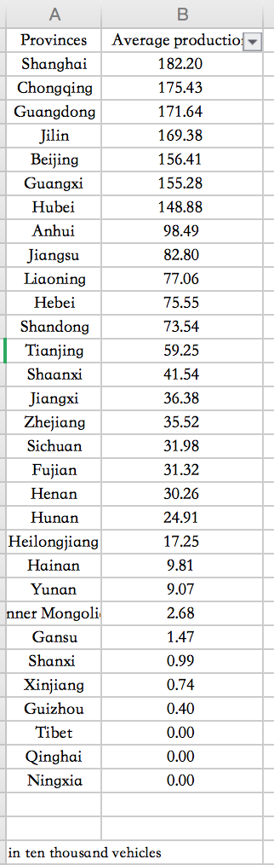  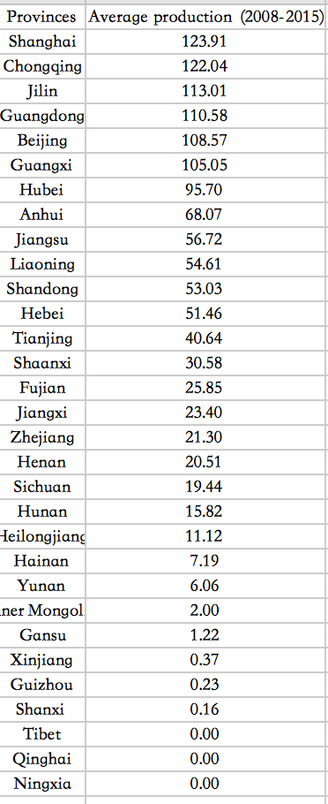

**Chart 4 Human: drivers, population**

Compiling the data about civilian-owned cars and population, I found residence in Beijing, following by Zhejiang, and Jiangsu, has the highest percent of car ownership while residence from Hunan and Jiangxi has the lowest. Beijing, Zhejiang and Jiangsu are also the top province with car license. However, Shanghai residence don’t like buying cars since it has more car drivers and less cars.

This is also the case happened to residence in Jiangxi, Hubei and Guangxi. Every 2.21 car drivers in Jiangxi own a car. Car drivers in Hainan have their own cars.

